# **PF LAB:6**

**24K-O514**

**MUHAMMAD**

**UMER FAROOQ**

# QUESTION 1:

Which loop system would be better for user input. Justify your answer by creating a program that takes a value and adds it to a variable and prints it repeatedly until the user enters a zero value.

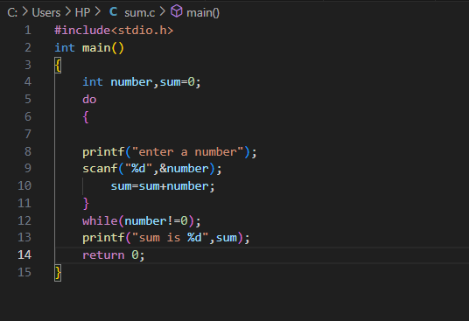

OUTPUT:

## QUESTION 2:

Write a program to check whether a given number is a multiple digit number or not.

OUTPUT:

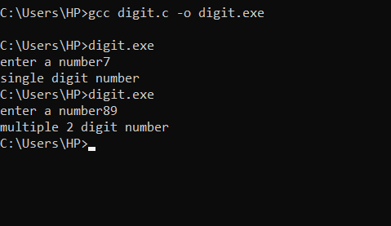

### QUESTION 3:

Using the above program integrate the number if it is a prime or composite number.

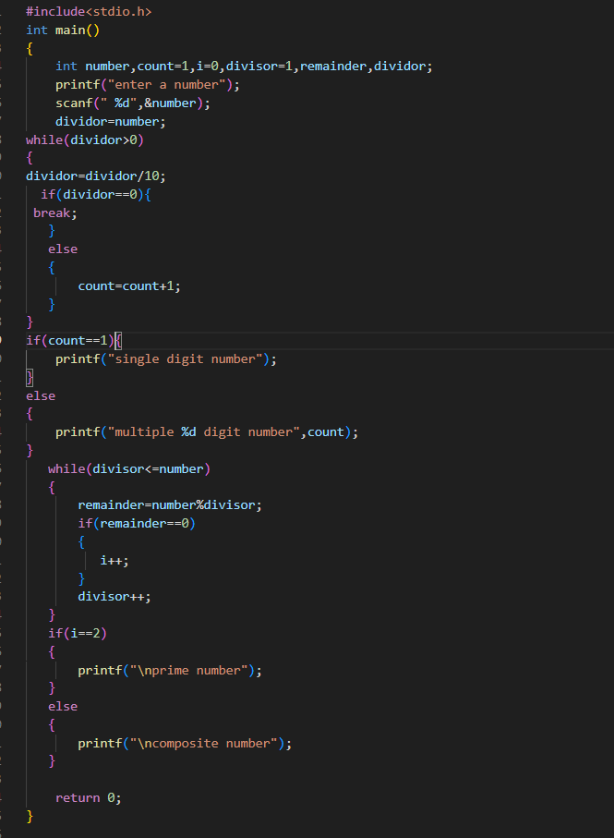

OUTPUT:

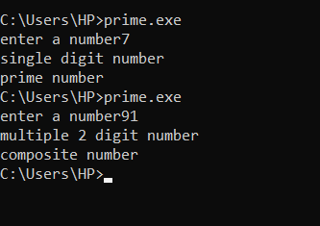

#### QUESTION 4:

Write a program to print the following series: 1, 2, 3, 5, 8, 13.

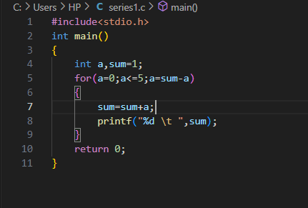

OUTPUT:

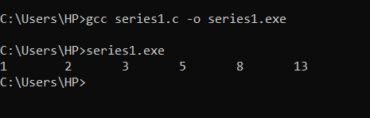

##### QUESTION 5:

Using for-loop statement print the following series:



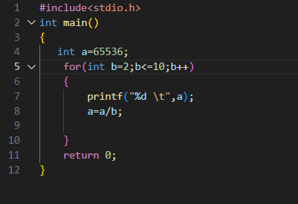

OUTPUT:

###### QUESTION 6:

Create a C program to calculate the following series using loop statements.,



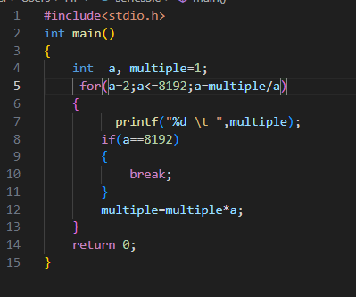

OUTPUT:

